**Assessment 1**

**Overview**: UIA (Ultimate Institute of Australia) is a college which is providing IT training and established in 1980 providing best education throughout Australia in a very effective way. UIA is committed to empowering students with the knowledge and skills to succeed, and continue lifelong learning in their chosen field. We achieve this through orientation programs contextualized for current and future industry needs and standards.

**Project Objectives**: The main objectives of project is to develop website of UIA in online and give feedback to learners from websites and helps to save time. After, this project the online presence will be increased. The project will be implemented within 3 weeks.

**Project Constraints:** The budget and time of this projects is limited. The website has limited time to complete as there are a small number of web developers where more programmers may be required.

**Project Risks**: Cost risk, lack of time management and limited knowledge of web development.

**Business Requirements:** The key point to build this website is to increase number of online customers. UIA requires to open online video tutorials for different IT courses. Even they want to sell their courses materials like practice questions, mock tests, notes and video as a package for variety of courses.

**Architecture:** The functionality of the website requires HTML, CSS and JavaScript.

**Development:** In some cases while creating the website JavaScript will be used instead of HTML for certain functionality. Time and date were inserted using JavaScript instead of HTML.

**Testing:** The website was tested on different desktops and browsers. As a result chrome and Firefox showed fast response as opera mini didn’t loaded as fast as other browser.

**Screenshots of website**





**Code Sample**

**CSS**:

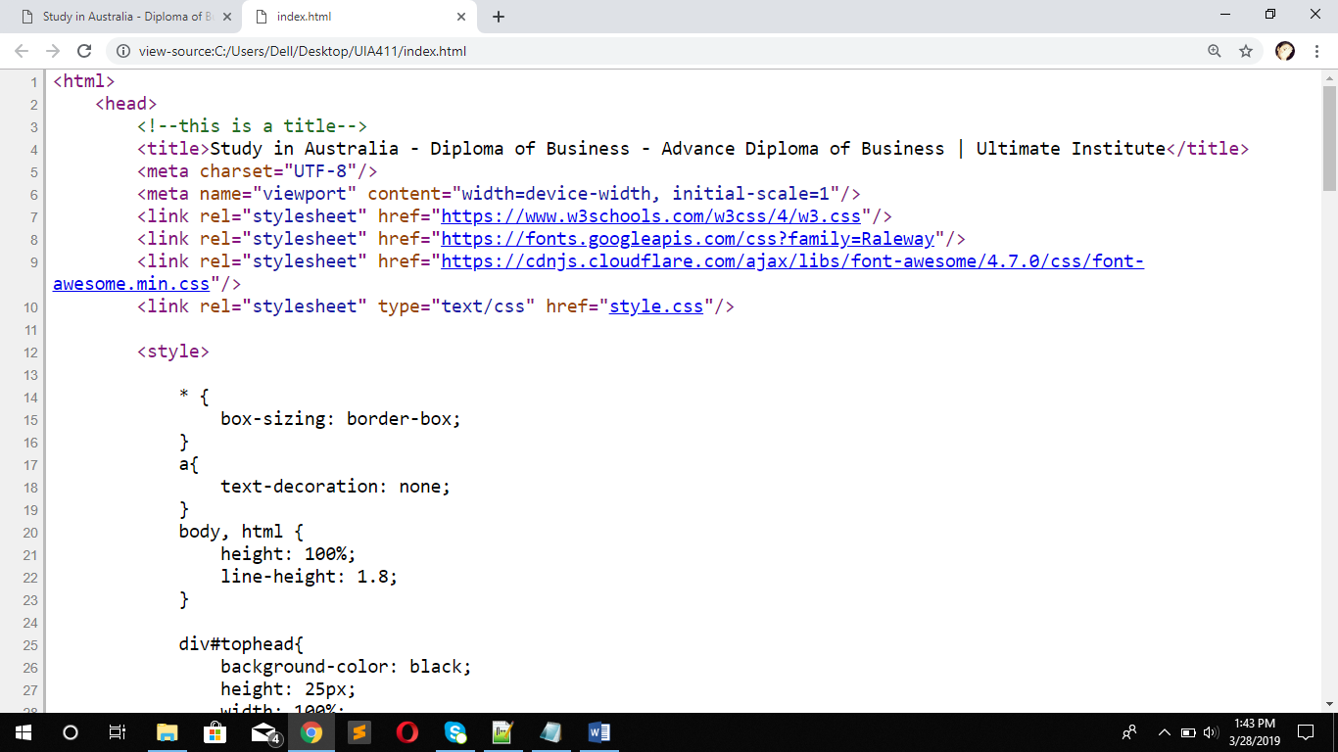

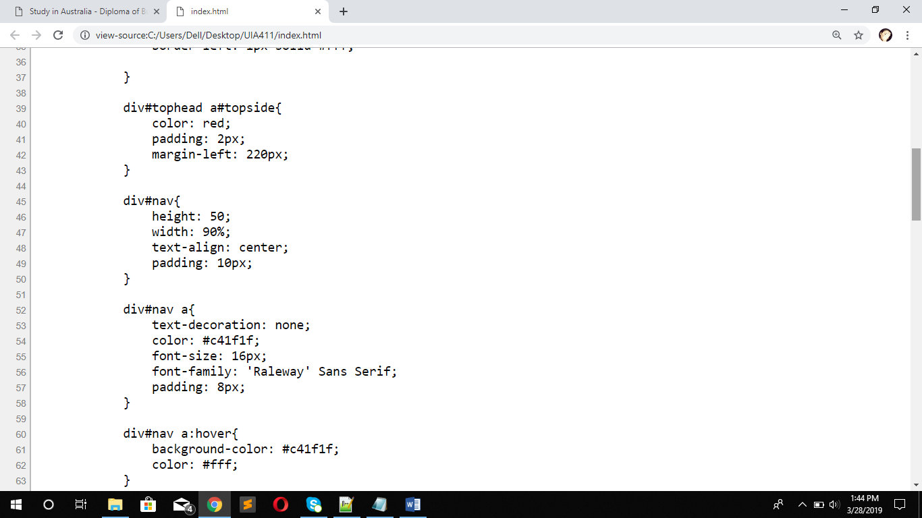

**HTML:**

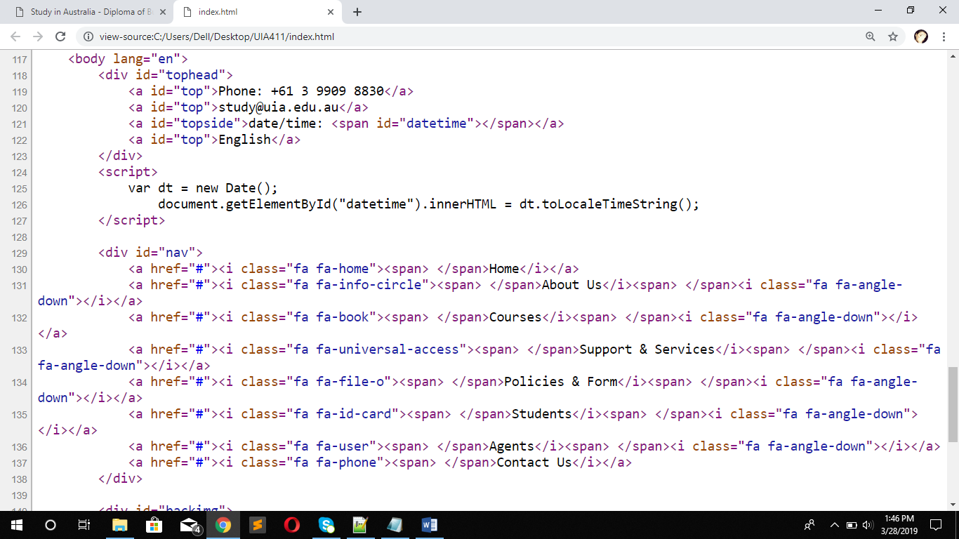

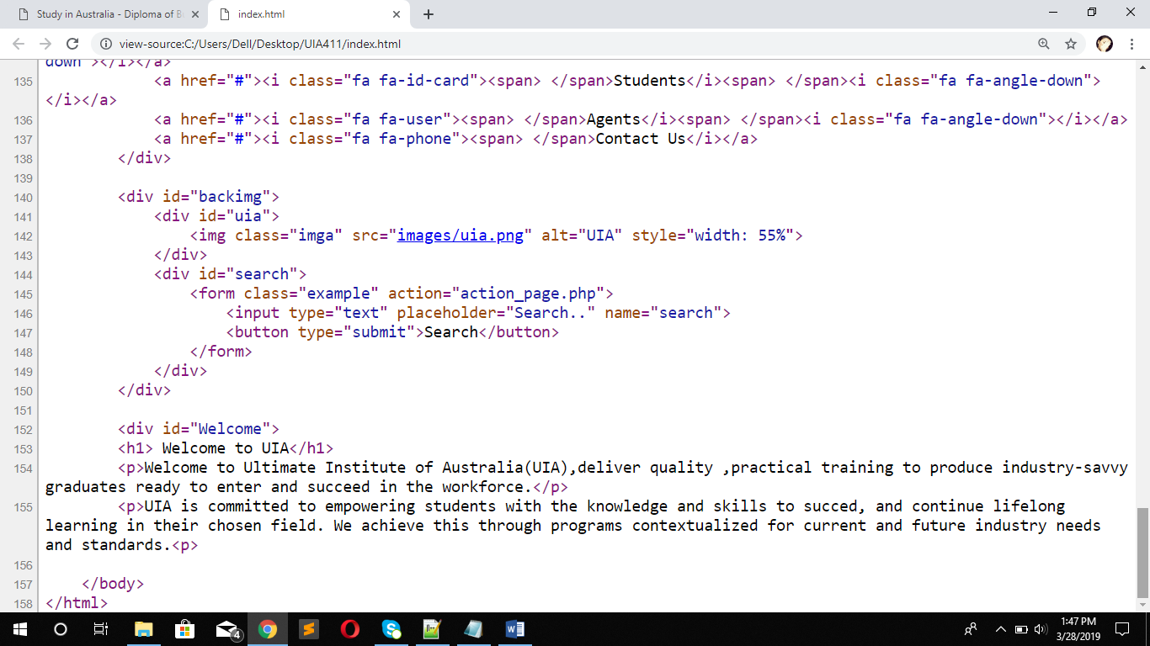

**Project Resources**:

* Roles and Responsibility – the developers are responsible for developing the website and handover to UIA if there is any issue with the website in the future.
* Issue Escalation – This will initially be covered by develops and escalated to business stakeholders if problem cannot be fixed.
* Project Materials – Primarily laptops and PC’s are required to complete the project as the code will be tested on different devices to discover any known risks.

**Project Approach**

* + **Development Model** –The initial version was built primarily using HTML and CSS for its basic foundation. Version 2 required data and time on just the homepage for easy user experience.
  + **Configuration Management** – Website versioning will be updated once agreed during stakeholder management meetings.
  + **Communication Management** – Every 2 weeks the stakeholders and developersdiscuss website development issues to be solved.
  + **Change Management** – The website was only changed once agreement was made with the key staff stakeholders.
* **Estimate**
* The website project estimate will be $2000, this is due to hardware cost of around $1000 and rest of the money towards developer labor.
* **Schedule**

The project will start on June 4th 2020 and due to be completed end on June 24th 2020.

**Website elements required:**

1. Site navigation - front end design must be easily applied to the entire site (keep similar look for all pages)

2. Page design- menu and quick links on all pages - 2 click rule between pages

3. Create website template - create Home page - list business products and services and show date and time, create subscribe button on all pages, Contact page, Blog page – with recent updates, Link to external website (social media ?), Download page for adobe & Feedback page – put an email link

3. Content filter- display information based on criteria or keyword

4. Feedback forms - various forms (registries and guestbook) on the website, collect visitor information send to an email address

5. News column - updates (blogs) must be displayed on homepage

6. Changing the style and position of displayed elements dynamically (i.e. text font, color, size or image)

7. Date and time - show current date and time on homepage only of website

8. Security requirement - data validation - check the correct user input

Main points - check all links, check in different browsers, ensure you have applied metadata (titles), and check window sizes, easy navigation & friendly URLS

9. Once complete provide with Project report for sign off

**Client Sign Off ………………………………… Date …………………………………**